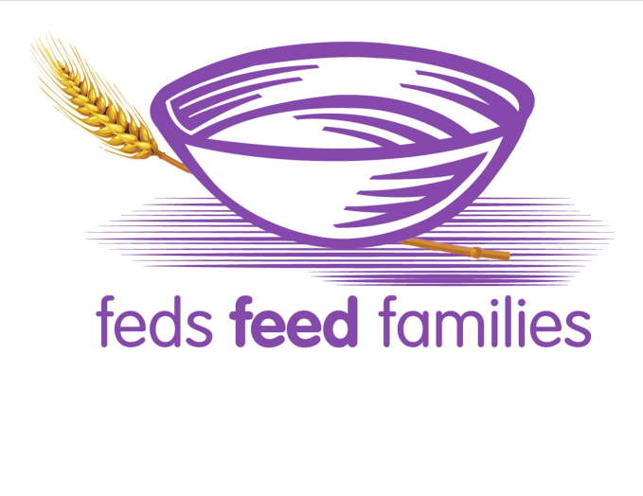
BOX REQUEST INSTRUCTIONS
for delivery in the DC metropolitan area

To receive boxes submit an email to
fedsfeedfamilies@usda.gov with the following:
- Email subject line: Box Request [insert your agency name, include parent agency if applicable]
- Your name and telephone number
- The number of boxes needed (Holds up to 200 pounds)
- The number of pallets needed (Holds up to 4 boxes)
- Agency address
- POC and Alternate POC name (for the loading dock), telephone number (cell phone preferred) and email address
- Loading dock address and special loading dock instructions ex. (loading dock times of operations, security check points)

